

Practices for Secure Software Report

Table of Contents
Document Revision History 3
Client 3
Instructions 3
Developer 4
1. Algorithm Cipher 4
2. Certificate Generation 5
3. Deploy Cipher 5
4. Secure Communications 6
5. Secondary Testing 6
6. Functional Testing 6
7. Summary 6
8. Industry Standard Best Practices 6

Document Revision History

Version | Date | Author | Comments
1.0 | February 17, 2026 | Cynthia Knox | Initial Create

Client



Instructions

Submit this completed practices for secure software report. Replace the bracketed text with the relevant information. You must document your process for writing secure communications and refactoring code that complies with software security testing protocols.

- Respond to the steps outlined below and include your findings.
- Respond using your own words. You may also choose to include images or supporting materials. If you include them, make certain to insert them in all the relevant locations in the document.
- Refer to the Project Two Guidelines and Rubric for more detailed instructions about each section of the template.

Developer
Cynthia Knox

Algorithm Cipher

A. Provide a brief, high-level overview of the encryption algorithm cipher.
The request for Artemis Financial is to add a file verification step to the web application to ensure secure communication. When the web application is used to transfer data, Artemis Financial will need a data verification step in the form of a checksum. While reading through all the resource material, a symmetric cipher should be chosen. Asymmetric Ciphers are considered “Public Key Encryption” (Goldstein, 2022). The use of encryption is intended for secure communication as well as archiving files. I decided to research the most secure and popular ciphers, and Advanced Encryption Standard (AES) was returned. Further investigation of AES determined that this was the best choice for secure file encryption and communication. AES is a symmetric cipher and is considered to be the “Gold Standard” and can be used for File Encryption.
- Discuss the hash functions and bit levels of the cipher.

A hash is an output of a hashing algorithm. Popular hashing algorithms like MD5 (Message Digest 5) or SHA (Secure Hash Algorithm) are currently in use. Hashing scrambles data to ensure integrity when the message arrives at its destination. If any part of the message was altered during transit, the hash will not match the original value. It is a one-way process and ensures data integrity. The bit levels identify the final length of the hash output, or digest. SHA-256 is 256 bits with 32-bit words. SHA-512 is 512 bits with 64-bit words (d). The larger the value, the longer it would take to generate the same data. While 512 is more secure, it is not widely used yet and could have limitations (Mehta, 2026. GCR Coach, 2025. N-Able, 2012)
- Explain the use of random numbers, symmetric versus non-symmetric keys, and so on.
Random numbers are used to generate the keys used in both symmetric and non-symmetric keys. For symmetric algorithms, a single private key is used for both the sender and the recipient. For non-symmetric algorithms, two different keys are created: a public key and private key. Random number generators are available in Java. (Oracle SecureRandom, 2017)
- Describe the history and current state of encryption algorithms.

Encryption algorithms are as old as Julius Ceasar, which was a simple substitution algorithm, the Ceasar Cipher. The modern algorithms began around the 1970s with Ron Rivest who invented the “RC” algorithm and created a series of algorithms. RC1 was never published. RC2 was a symmetric block algorithm. RC3 broke before it was ever used. RC4 is a stream cipher and a symmetric key encryption algorithm. RC5 was a simple algorithm and had a low memory requirement. If the key used is long, it is secure. If short, it is not. RC6 was a candidate for the AES, as designed. (Charbathia, Sharma. 2014) In the future, encryption algorithms will have to be safe against quantum computing. New algorithms are being developed such as CRYSTALS-Kyber, which is safe for general encryption. (Miller, 2026

Certificate Generation

Security Observation:
The Eclipse “Keytool” Plugin generates a certificate that uses SHA-1 and V1. Since there is no current available configuration, the recommended remedy is that the certificate generation process is run manually with SHA-256 and RSA-2048 in order to comply with modern software security testing protocols and ensure the "well-being" of Artemis Financial's data.
Below is an example of the Eclipse Keytool generated certificate (right), as compared to the manually-generated Keytool certificate via command line with specified requirements:

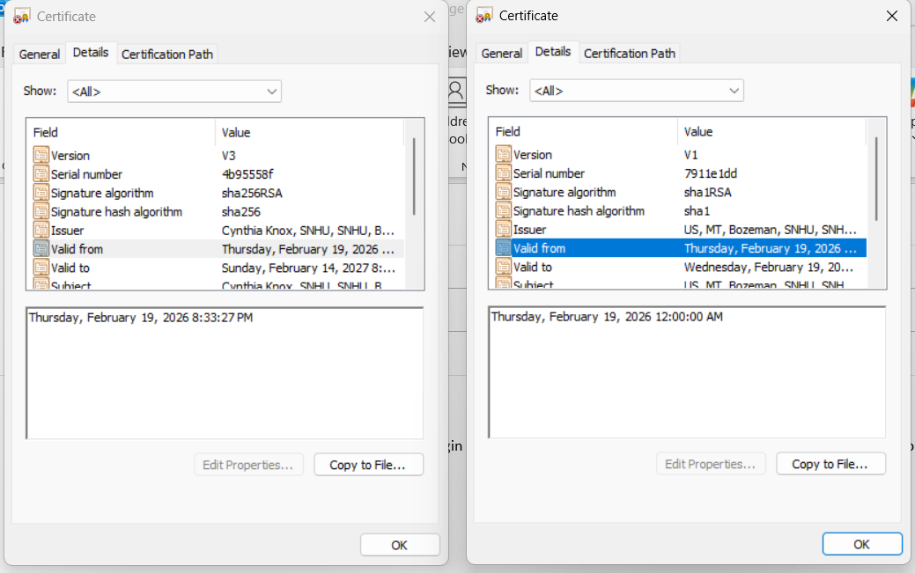
.
Certificate per Eclipse Keytool:
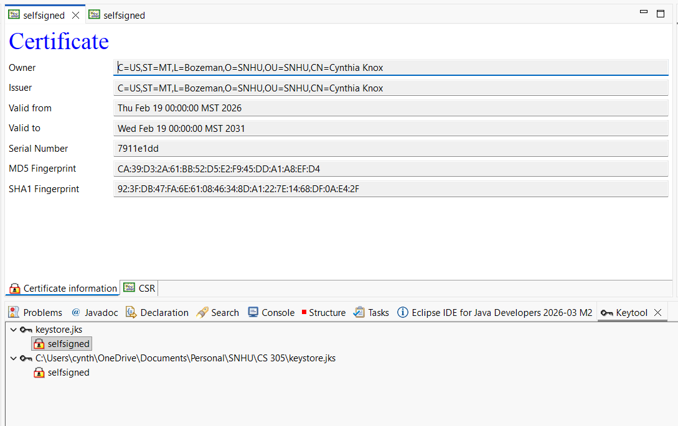

Deploy Cipher
Insert a screenshot below of the checksum verification.

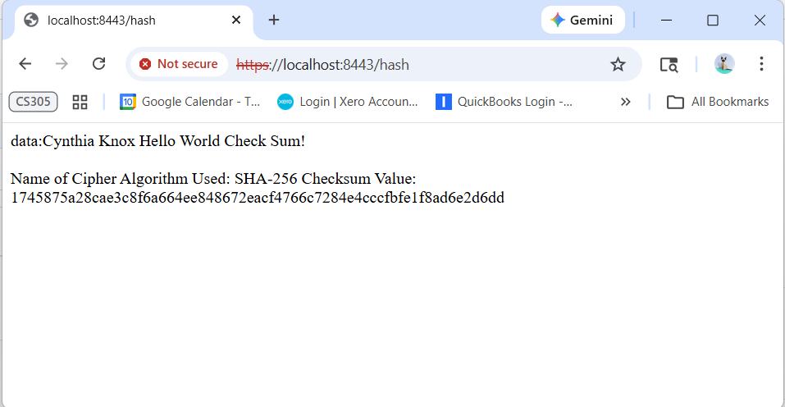

Secure Communications
Insert a screenshot below of the web browser that shows a secure webpage.

As displayed below, the site is accessed via HTTPS:

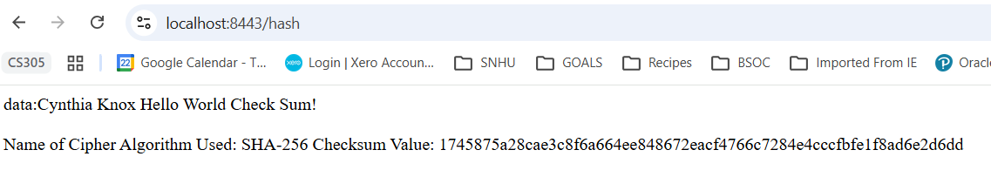

Secondary Testing
Insert screenshots below of the refactored code executed without errors and the dependency-check report.
- A screenshot of the refactored code executed without errors
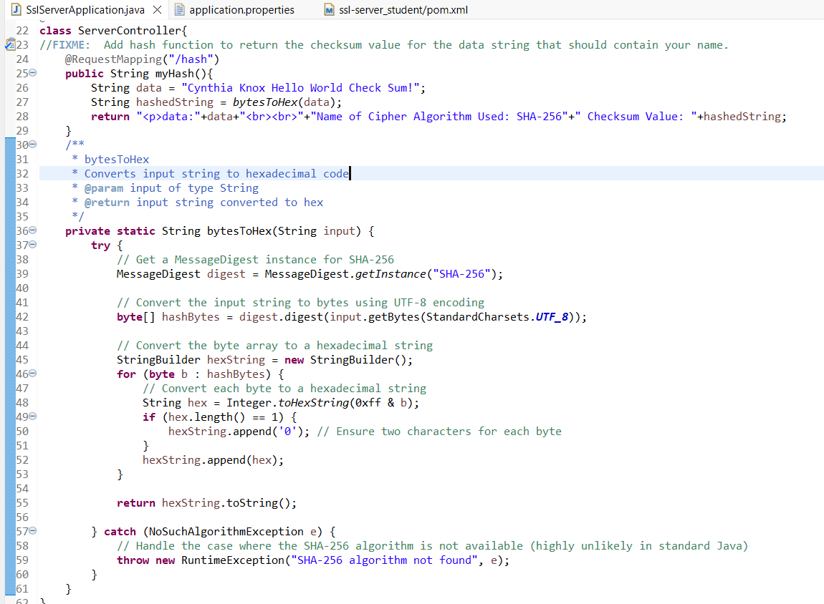
- A screenshot of the report of the output from the dependency-check static tester
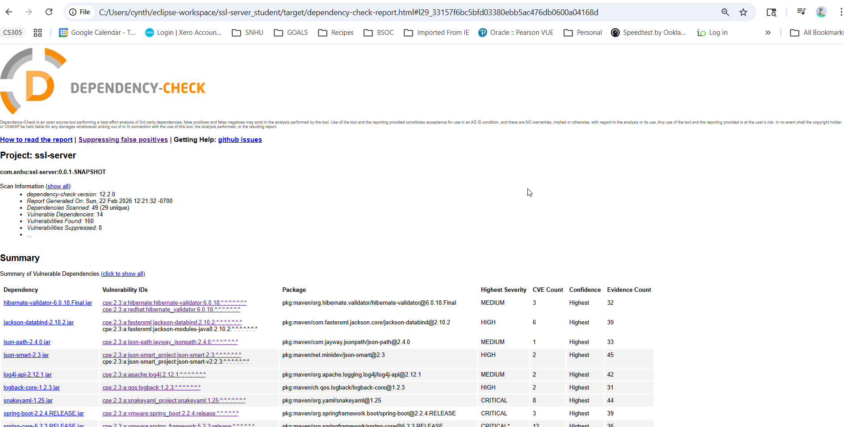

AFTER upgrading Spring:
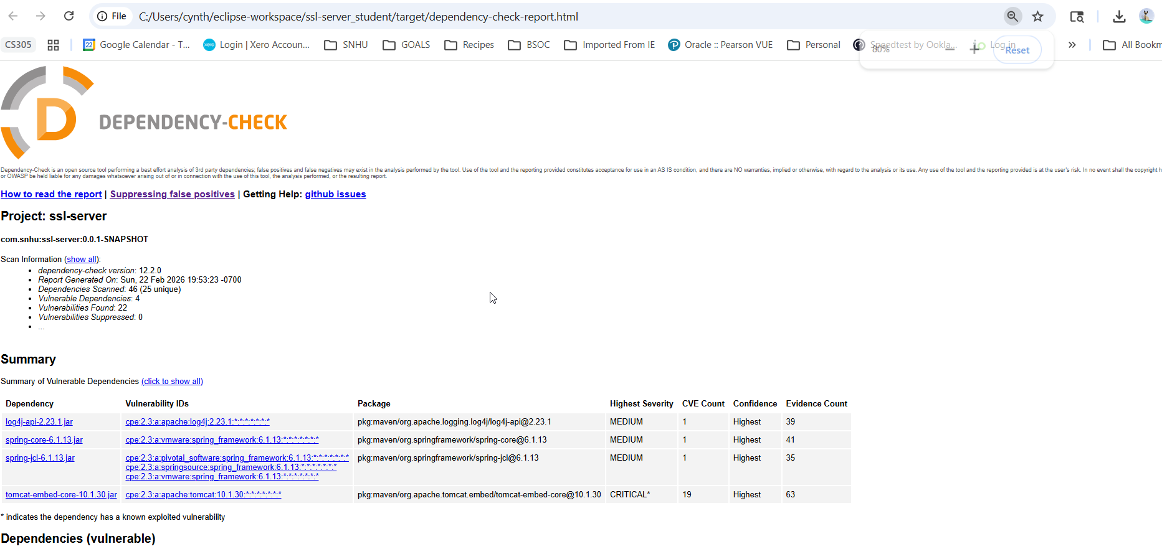

- Functional Testing
Identify the software application's syntactical, logical, and security vulnerabilities by manually reviewing the code:
Input Validation:
SslServerApplication.java: Line 26– Currently, the input data is hard-coded. However, once pulled from the input, it will need to have a wrapper to validate the input data. Also, a REST Endpoint was added to interface with a method that will return the checksum of input data.
(OWASP, 2010)
APIs:
For secure data transfer, the rest-service project is setup with HTTP and has been setup with certificates and refactored to use HTTPS as per OWASP Guide, “Session Management” [72].
Cryptography (Optional): Within the file Application.properties it was updated with the information from the newly generated certificate. We will ensure HTTPS is implemented. Certificates were generated and TLS via port 8443 was implemented for HTTPS as per OWASP “Authentication and Password Management” [30].
Client/Server: Again, ensured HTTPS is utilized as well as Transport Layer Security (TLS) for data enroute as per OWASP “Session Management”
Code Quality:
Code Error:
SslServerApplication.java – The NoSuchAlgorithmException ensures that a generic message is written out if no internal server details are written to the browser page, as per OWASP “Error Handling and Logging” [108]. In the future, we will ensure the following Log Event Data is captured:
1. Time stamp from a trusted system component
2. Severity rating for each event
3. Tagging of security relevant events, if they are mixed with other log entries
4. Identity of the account/user that caused the event
5. Source IP address associated with the request
6. Event outcome (success or failure)
7. Description of the event

Dependency Files Check
pom.xml - (spring-web (version 5.2.3) and spring-boot (version 2.2.4) needs to be upgraded to the most current version. Refer to CVE and NVD databases.
Insert a screenshot below of the refactored code executed without errors:

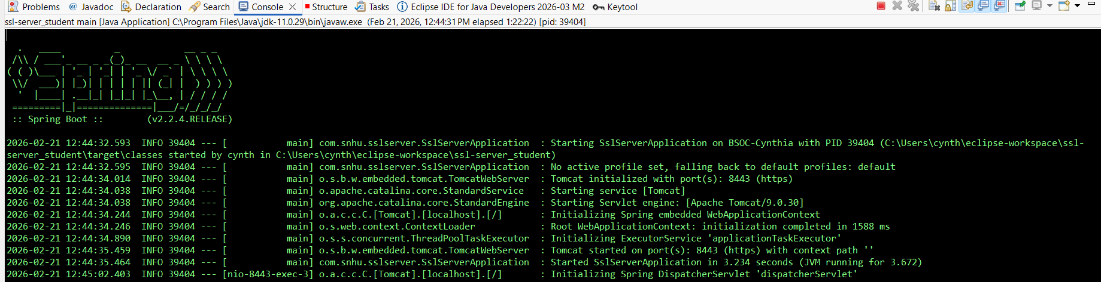

Summary

A code review and security analysis were performed. Code was refactored to include a REST API for the hashing function. The API endpoint is available over HTTPS, and certificates implementing SHA-256 were created and installed. The OWASP Dependency Check was performed and false positives were suppressed. Dependencies identified in the report may have to be upgraded to the current version.

Industry Standard Best Practices

Recommended Security protection best practices:
- Choosing the right algorithm. Do extensive research to understand which algorithm best suits the given business needs.
- Managing Encryption keys effectively. Ensure secure storage, tight access controls and regular rotation of the keys.
- Keep up with the latest technology and techniques as they develop rapidly. Do regular audits and penetration testing.
(Ertl, 2024)
Further, additional general Secure Software Best Practices should include at least:
- Default Deny and Principle of Least Privilege – Implementation of Role-Based access control (RBAC) or Attribute-based access control. Review privilege assignments regularly. Use a “Deny All” as default state for APIs, file systems and services.
- Proper Error handling and Logging and Logging – proper error handling is required to prevent internal data being exposed. Ensure Logging events in structured formats are handled. Use secure storage and encryption for log archives. Ensure stack traces are not logged in production. Mask user and personal data.
- Secure Coding – Require code reviews, adhere to OWASP Secure Coding Practices.
Implement Multi-Factor Authentication. (Security Journey, 2026).
4. References
Goldstein, Phil. (2022). What's the Difference Between Hashing and Encryption for Agencies? https://fedtechmagazine.com/article/2022/01/what-difference-between-hashing-and-encryption-federal-agencies-perfcon
Kidd, C. (2024, October 18). Data Encryption Methods & Types: A Beginner's Guide. https://www.splunk.com/en_us/blog/learn/data-encryption-methods-types.html#:~:text=for%20your%20business.-,Advanced%20Encryption%20Standard%20(AES),SSL/TLS%20protocols
Ertl, B. (2024, June 14). Essential Data Encryption Best Practices. https://www.kiteworks.com/secure-file-sharing/secure-file-sharing-essential-data-encryption-best-practices/#Best_Practices_for_Data_Encryption
Security Journey. (2026). 9 Best Practices for Secure Coding in 2026.
https://www.securityjourney.com/post/best-practices-for-secure-coding
Oracle (2017). Java Security Standard Algorithm Names. https://docs.oracle.com/javase/9/docs/specs/security/standard-names.html#cipher-algorithm-names
Federal Trade Commission (FTC). (2026). Gramm-Leach-Bliley Act. https://www.ftc.gov/business-guidance/privacy-security/gramm-leach-bliley-act
GCR Coach (2025) https://www.youtube.com/watch?v=ldMpT-SKXh4&t=139s
Security First Corp. (2025). Blowfish Vs AES? - SecurityFirstCorp.com https://www.youtube.com/watch?v=VMOsQSMUYDM&t=11s

